Title (Times New Roman, 16pt., Bold)
Names of the authors (Times New Roman, 12 pt., Bold). Family names capitalized. Corresponding author underlined.
1) Affiliation, postal address, email address (Times New Roman, 12 pt., regular) of the first author. Email address of the corresponding author underlined.
2) Affiliation, postal address, email address (Times New Roman, 12 pt., regular) of the second author etc.

Main text (Times New Roman, 12 pt., regular). The first line of each paragraph must be indented 12.5 mm. Single spaced.
Maximum extent size is 2 pages including spaces, heading, names, addresses, body text, and figures. Abstract must be written in English. Authors are advised to prepare their abstracts using this template. The paper size is A4. The number of references should be minimized.

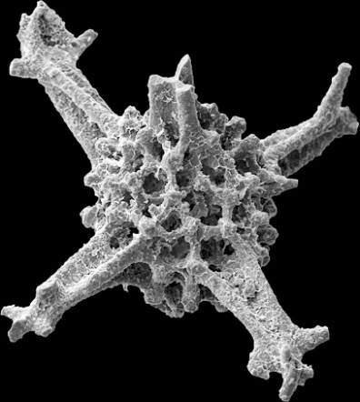
Figure 1. (Times New Roman, 10.5 pt., Bold) Thurstonia robusta Cifer, in Cifer et al., 2020. Caption is required. (Times New Roman, 10.5 pt., regular)
Figures (drawings and photographs) are permitted. Color figures are acceptable. The caption is required for each figure.
References (Times New Roman, 12 pt., Bold)
The references should be ordered alphabetically (Times New Roman, 12 pt., regular).
Please, use the following formatting:
Cifer T., Goričan Š., Gawlick H.-J., Auer, M. 2020. Pliensbachian, Early Jurassic radiolarians from Mount Rettenstein in the Northern Calcareous Alps, Austria. Acta Palaeontologica Polonica 65 (1): 167–207, https://doi.org/10.4202/app.00618.2019.
Keywords: Maximum 4.

For more examples of complete abstracts see the abstract book of the 15th InterRad in Niigata 2017, RADIOLARIA vol. 40:
http://interrad2017.random-walk.org/wp-content/uploads/2017/10/Abstracts_InterRadXV_171016b.pdf

